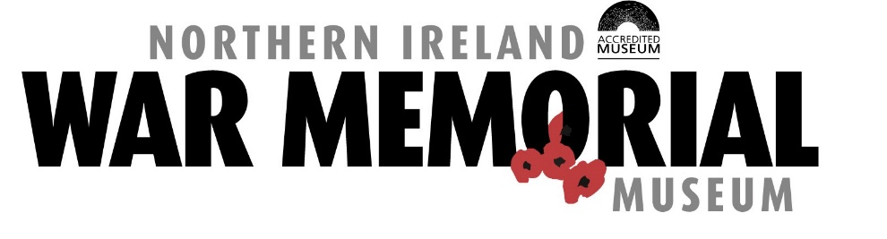

Small Grants Request Form

Please complete this form and return to: Victoria Gibson at 21 Talbot Street, Belfast, BT1 2LD or finance@niwarmemorial.org

NIWM Mission

The Northern Ireland War Memorial was established to provide an enduring memorial for the men and women of Northern Ireland who died in the two World Wars, and to commemorate the American presence in Northern Ireland during the Second World War.
Now an Accredited Museum, our mission is to tell the story of Northern Ireland’s role in the Second World War comprehensively and authentically through engaging exhibitions, publications, research, outreach and accessible learning programmes. In addition, we maintain war memorials to the fallen in the First and Second World War and the Belfast Blitz. We organise respectful commemorations, provide office and meeting accommodation to ex-service charities, and award small grants to projects which are in line with our charitable objectives.
Small Grants Scheme
- Applicants must demonstrate that the grant will be applied to projects which are in line with the Mission of the NIWM.
- Projects must demonstrate that added value will accrue as a result of the grant.
- Under NI charity law, grants must be expended on local projects and activities.

Your contact details

Title (Mr/Miss/Mrs/Ms/Dr/ Other)
First name(s)
Surname
Current occupation/position
Address
Postcode:
Email address
Daytime telephone number
Preferred method of contact

About your organisation (please use a separate sheet if required)

Outline below the amount of grant you are requesting, your reason for applying for the grant and describe how you fill the criteria above (please use a separate sheet if required)

I declare the information I have provided is true:
Signed .....................................
Date ...................

